Auto Water Pump Switcher

In many Places time for water supply is not fixed. It may be in early morning hours or anytime in a whole day. These creates many problems for a concerned person you have to wake up early, just to switch on your motor pump and wait till your water tank is filled up.
So, Here we have designed a simple idea which simply turns on or off your pump according to your water supply. The controller system works on a 555 IC with a water-level sensing arrangement. So whenever the incoming water is sensed the relay circuit simply switches the Pump On and when the water supply is off the relay switches off the motor.
Hence This is a simple and a low-cost automatic water pump motor controller which makes your everyday water pump related problem quite easy

Block Diagram:
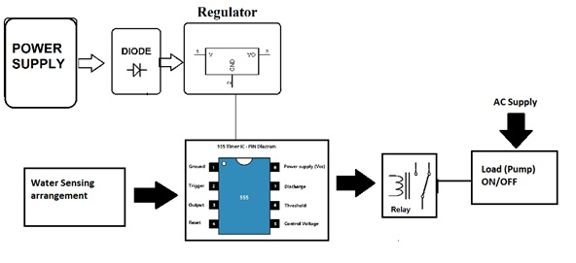
Hardware Specifications

- Relay

- Crystal Oscillator
- Resistors

- Capacitors

- Transistors
- Cables and Connectors

- Diodes

- PCB and Breadboards
- LED

- Transformer/Adapter

- Push Buttons
- Switch

- IC

- IC Sockets
Software Specifications

- MPLAB

- MC Programming Language: C

